**上机实验4**

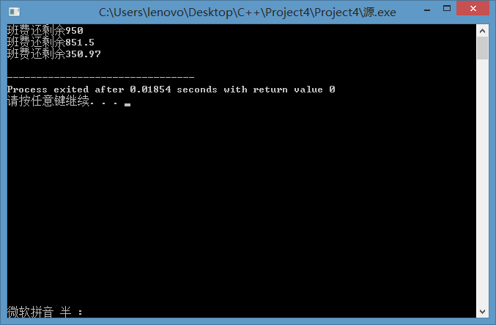

程序：

#include <iostream>

using namespace std;

class TSstudent

{

public:

float money;

static double m_ClassMoney;

void InitStudent()

{

char name[100];

}

void ExpendMoney(double a)

{

money = a;

}

double ShowMoney()

{

m_ClassMoney-=money;

return m_ClassMoney;

}

};

double TSstudent::m_ClassMoney = 1000;

int main()

{

TSstudent A;

TSstudent B;

TSstudent C;

A.ExpendMoney(50);

cout << "班费还剩余" << A.ShowMoney() << endl;

B.ExpendMoney(98.5);

cout << "班费还剩余" << B.ShowMoney() << endl;

C.ExpendMoney(500.53);

cout << "班费还剩余" << C.ShowMoney() << endl;

return 0;

}

心得：静态成员可以封装这些算法，调用简单。